**### Timesheet Automation CAS Project**

** Team **

1. NISHANT BADU - 2303472

2. K ABHISHEK- 2303558

3. GURUMALLESH M S - 2303549

4. SUNIL N -2303571

5. SWAPNALI DEBATA-2303471

---------------------------------------------------------------------------

URL for Mainspring: “https://be.cognizant.com/”

Frameworks & Tools Used:

·    Selenium Web Driver

·    Maven

·    TestNG

·    Extent Reports API

·    Apache POI

·    Page Object Model

Procedure for accessing:

1.Launch Be.Cognizant website.

2.Get the current user details and print it in the console.

3.In start searching text box type Timesheet and click search icon.

4.Click Submit Timesheet option among the listed results.

5.The timesheet page is opened, then we need to retrieve the different status that are available in the list.

Conclusion:

The results of all the test cases will be displayed in the console. The Extent report of the project will be generated once the automation gets completed. All the screenshots will be available in the “Screenshot” folder.

ScreenShots:

1.ScreenShot of searching Timesheet page.

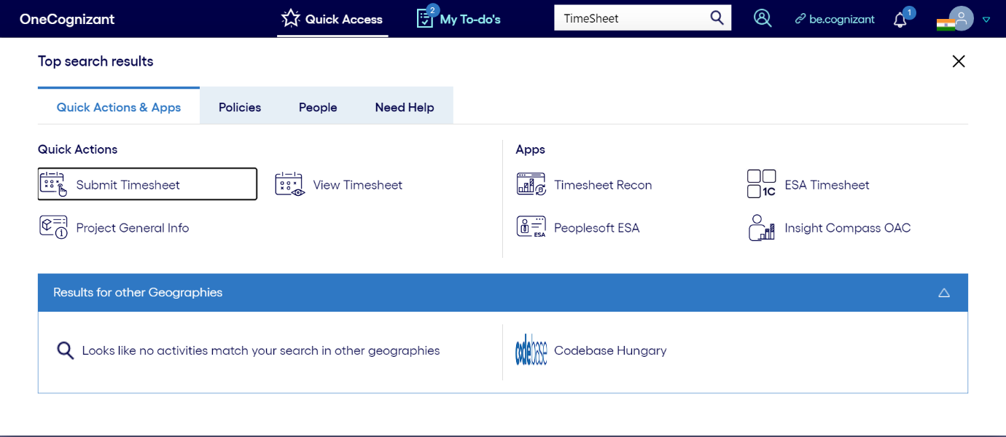

2.ScreenShot of user information.

3. Screenshot of Timesheet Page

